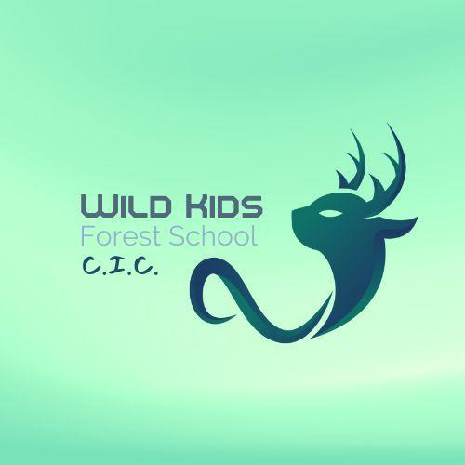

Referral Form - Alternative Provision Forest School
Please complete this form to refer a student to our Alternative Provision Forest School.

Student Information

- Student's Full Name:
- Date of Birth:
- Address:
- Parent/Guardian Name(s):

Referers Information

- School Name(if applicable):
- Referring Staff Name and Title/ Name of Parent:
- Contact Phone Number:
- Email Address:

Reason for Referral

Please provide a detailed explanation of why the student is being referred to the Alternative Provision Forest School, including any specific behavioral, emotional, or learning needs.

Additional Information

Please provide any relevant supporting documents, such as educational reports, medical information, or behavioral plans. It would be helpful if EHCP Targets or desired outcomes could be highlighted for us to better create a bespoke support plan. Please also include your budget so that we can negotiate a package that works for everyone.

Document | Description

Expectations

Please use this section to let us know any expectations you may require specific to your child or if you are a parent referrer, what would you like your child to get from our service.

Consent

I confirm that I have discussed this referral with the student's parent/guardian and they have given their consent for the referral to be made.

AND/OR

I give permission to hold this information in line with GDPR regulations for the sole use of Wild Kids Forest School CIC.

- Signature of Referer:
- Date:

